A Course Material on

**Satellite Communication**

By

**S.CHANDRAMOHAN**

Assistant Professor



**DEPARTMENT OF ELECTRONICS AND COMMUNICATION ENGINEERING**

SRI CHANDRASEKHARENDRA SARASWATHI

VISWA MAHAVIDYALAYA

(Deemed to be University established under section 3 of UGC act 1956)

ENATHUR, KANCHIPURAM – 631 561

**SATELLITE COMMUNICATION**

**AIM**

To enable the student to become familiar with satellites and satellite services.

**OBJECTIVES**

* Overview of satellite systems in relation to other terrestrial systems.
* Study of satellite orbits and launching.
* Study of earth segment and space segment components
* Study of satellite access by various users.
* Study of DTH and compression standards.

**UNIT I SATELLITE ORBITS:**

Kepler’s Laws, Newton’s law, orbital parameters, orbital perturbations, station keeping, geo stationary and non Geo-stationary orbits – Look Angle Determination- Limits of visibility –eclipse-Sub satellite point –Sun transit outage-Launching Procedures – launch vehicles and propulsion.

**UNIT II SPACE SEGMENT AND SATELLITE LINK DESIGN:**

Spacecraft Technology- Structure, Primary power, Attitude and Orbit control, Thermal control and Propulsion, communication Payload and supporting subsystems, Telemetry, Tracking and command. Satellite uplink and downlink Analysis and Design, link budget , E/N calculation- performance impairments-system noise, inter modulation and interference, Propagation Characteristics and Frequency considerations – System reliability and design lifetime.

**UNIT III SATELLITE ACCESS:**

Modulation and Multiplexing: Voice, Data, Video, Analog – digital transmission system, Digital video Brodcast, multiple access: FDMA, TDMA, CDMA, Assignment Methods, Spread Spectrum communication, compression – encryption

**UNIT IV EARTH SEGMENT:**

Earth Station Technology-- Terrestrial Interface, Transmitter and Receiver, Antenna Systems TVRO, MATV, CATV, Test Equipment Measurements on G/T, C/No, EIRP, Antenna Gain.

**UNIT V SATELLITE APPLICATIONS:**

INTELSAT Series, INSAT, VSAT, Mobile satellite services: GSM, GPS, INMARSAT, LEO, MEO, Satellite avigational System. Direct Broadcast satellites (DBS)- Direct to home Broadcast (DTH), Digital audio broadcast (DAB)- Worldspace services, Business TV(BTV), GRAMSAT, Specialized services – E –mail, Video conferencing, Internet.

**TEXT BOOKS:**

1. Dennis Roddy, ‘Satellite Communication’, McGraw Hill International, 4th Edition, 2006.

2. Wilbur L. Pritchard, Hendri G. Suyderhoud, Robert A. Nelson, ‘Satellite Communication

Systems Engineering’, Prentice Hall/Pearson, 2007.

**REFERENCES:**

1. N.Agarwal, ‘Design of Geosynchronous Space Craft, Prentice Hall, 1986.

2. Bruce R. Elbert, ‘The Satellite Communication Applications’ Hand Book, Artech

## Introduction to Satellite Communication

Satellites are specifically made for the purpose of telecommunication. They are used for mobile applications such as communication to ships, vehicles, planes, hand-held terminals, TV and Radio broadcasting. They are responsible for providing these services to an assigned region on the earth. The power and bandwidth of these satellites depend upon the size of the footprint, complexity of traffic control protocol schemes and the cost of ground stations.

A satellite works most efficiently when the transmissions are focused with a desired area. When the area is focused, then the emissions don’t go outside that designated area and thus minimizing the interference to other systems. This leads to more efficient spectrum usage.

Satellite’s antenna patterns play an important role and must be designed to best cover the designated geographical area. Satellites should be designed by keeping in mind its usability for short and long term effects throughout its life time.

The earth station should be in a position to control the satellite if it drifts from its orbit and if subjected to any kind of drag from the external forces. The following are the applications of satellites.

* + - Weather Forecasting
    - Radio and TV Broadcasting
    - Military Satellites
    - Navigation Satellites
    - Global Telephone
    - Connecting Remote Area
    - Global Mobile Communication

## Kepler’s laws

Satellites orbiting the earth follow the same laws that govern the motion of the planets around the sun. Kepler’s laws apply quite generally to any two bodies in space which interact through gravitation. The massive of the two bodies is referred to as the *primary* and the other, the *secondary* or *satellite*.

### Kepler’s First Law

Kepler’s first law states that the path followed by a satellite around the primary will be an ellipse. An ellipse has two focal points *F*1 and *F*2 as shown in Figure 1.1. The center of mass of the two-body system, termed the *bary center,* is always center of the foci.

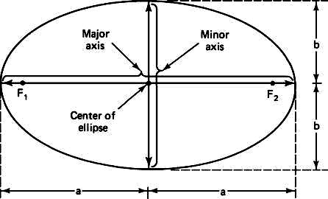The semi major axis of the ellipse is denoted by ‘*a’* and the semi minor axis, by ‘*b’*. The eccentricity ‘*e’* is given by

**Fig 1.1** Foci *F*1 and *F*2, the semi major axis *a*, and the semi minor axis *b* of an ellipse

### Kepler’s Second Law

Kepler’s second law states that for equal time intervals, a satellite will sweep out equal areas in its orbital plane focused at the bary center. Referring to Figure 1.2, assuming the satellite travels distances *S*1 and *S*2 meters in 1 second, then the areas *A*1 and *A*2 will be equal. The average velocity in each case is *S*1 and *S*2 m/s, and because of the equal area law, it follows that the velocity at *S*2 is less than that at *S*1.

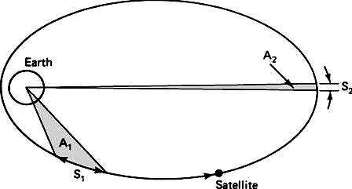

**Fig 1.2** The areas *A*1and *A*2 swept out in unit time are equal

### Kepler’s Third Law

Kepler’s third law states that the square of the periodic time of orbit is proportional to the cube of the mean distance between the two bodies. The mean distance is equal to the semi major axis *a*.

For the artificial satellites orbiting the earth, Kepler’s third law can be written in the form



Where ‘n’ is the mean motion of the satellite in radians per second and the earth‘s geocentric gravitational constant is given by



## Newton’s laws

### Newton's First law

An object at rest will remain at rest unless acted on by an unbalanced force. An object in motion continues in motion with the same speed and in the same direction unless acted upon by an unbalanced force. This law is also called "the law of inertia".

### Newton's Second law

Acceleration is produced when a force acts on a mass. The greater the mass (of the object being accelerated) the greater the amount of force needed (to accelerate the object).

### Newton's Third law

For every action there is an equal and opposite re-action. This means that for every force there is a reaction force that is equal in size, but opposite in direction. Whenever an object pushes another object it gets pushed back in the opposite direction equally hard.

## Orbital Parameters

**Apogee**: A point for a satellite farthest from the Earth. It is denoted as **ha. Perigee:** A point for a satellite closest from the Earth. It is denoted as **hp.**

**Line of Apsides**: Line joining perigee and apogee through centre of the Earth. It is the major axis of the orbit. One-half of this line‟s length is the semi-major axis equivalents to satellite’s mean distance from the Earth.

**Ascending Node:** The point where the orbit crosses the equatorial plane going from north to south

**Descending Node:** The point where the orbit crosses the equatorial plane going from south to north

**Inclination:** The angle between the orbital plane and the Earth’s equatorial plane. It’s measured at the ascending node from the equator to the orbit, going from East to North. This angle is commonly denoted as **i.**

**Line of Nodes:** The line joining the ascending and descending nodes through the centre of Earth.

**Prograde Orbit:** An orbit in which satellite moves in the same direction as the Earth’s rotation. Its inclination is always between 00 to 900. Many satellites follow this path as earth’s velocity makes it easier to lunch these satellites.

**Retrograde Orbit:** An orbit in which satellite moves in the same direction counter to the earth’s rotation.

**Argument of Perigee:** An angle from the point of perigee measure in the orbital plane at the earth’s centre, in the direction of the satellite motion.

**Right ascension of ascending node:** The definition of an orbit in space, the position of ascending node is specified. But as the Earth spins, the longitude of ascending node changes and cannot be used for reference. Thus for practical determination of an orbit, the longitude and time of crossing the ascending node are used. For absolute measurement, a fixed reference point in space is required. It could also be defined as “right ascension of the ascending node; right ascension is the angular position measured eastward along the celestial equator from the vernal equinox vector to the hour circle of the object”.

**Mean anamoly:** It gives the average value to the angular position of the satellite with reference to the perigee.

**True anamoly:** It is the angle from point of perigee to the satellite’s position, measured at the Earth’s centre.

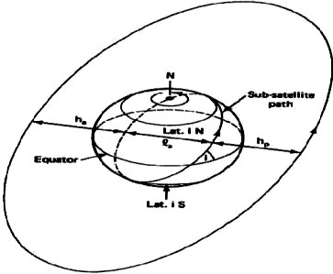

**Fig 1.3 A**pogee height *ha*, Perigee height *hp*, and inclination i; *La* is the line of a p s i d e s

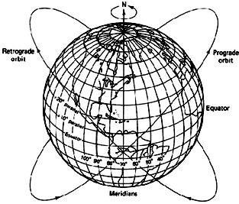

**Fig 1.4** Pro-grade and Retrograde Orbits

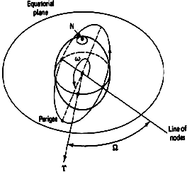

**Fig 1.5** Argument of Perigee ‘w’ and Right Ascension of the Ascending Node

## Orbital Perturbations

An orbit described by Kepler is ideal as Earth, considered to be a perfect sphere and the force acting around the Earth is the centrifugal force. This force is supposed to balance the gravitational pull of the earth. In reality, other forces also play an important role and affect the motion of the satellite. These forces are the gravitational forces of Sun and Moon along with the atmospheric drag. The effect of Sun and Moon is more pronounced on geostationary earth satellites where as the atmospheric drag effect is more pronounced for low earth orbit satellites.

### Effects of Non-Spherical Earth

As the shape of Earth is not a perfect sphere, it causes some variations in the path followed by the satellites around the primary. As the Earth is bulging from the equatorial belt, it is the forces resulting from an oblate Earth which act on the satellite produce a change in the orbital parameters. This causes the satellite to drift as a result of regression of the nodes and the latitude of the point of perigee. This leads to rotation of the line of apsides. As the orbit itself is moving with respect to the Earth, the resultant changes are seen in the values of argument of perigee and right ascension of ascending node.

Due to the non-spherical shape of Earth, one more effect called as the “Satellite Graveyard” is observed. The non-spherical shape leads to the small value of eccentricity at the equatorial plane. This causes a gravity gradient on GEO satellite and makes them drift to one of the two stable points which coincide with minor axis of the equatorial ellipse.

### Atmospheric Drag

For Low Earth orbiting satellites, the effect of atmospheric drag is more pronouncing. The impact of this drag is maximum at the point of perigee. The drag (pull towards the Earth) has an effect on velocity of Satellite. This causes the satellite not to reach the apogee height successive revolutions. This leads to a change in value of semi-major axis and eccentricity. Satellites in service are maneuvered by the earth station back to their original orbital position.

## Station Keeping

In addition to having its attitude controlled, it is important that a geo- stationary satellite be kept in its correct orbital slot. The equatorial ellipticity of the earth causes geostationary satellites to drift slowly along the orbit, to one of two stable points, at 75°E and 105°W. To counter this drift, an oppositely directed velocity component is imparted to the satellite by means of jets, which are pulsed once every 2 or 3 weeks. These maneuvers are called as *east-west station-keeping maneuvers*.

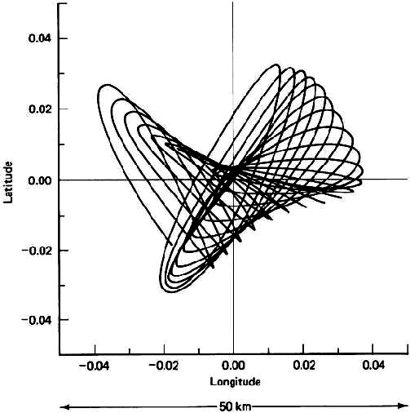Satellites in the 6/4-GHz band must be kept within 0.1° of the designated longitude and in the 14/12-GHz band, within 0.05°.

**Fig 1.5** Typical Satellite Motion

## Geo stationary and Non Geo-stationary orbits

### Geo stationary Orbit

A **geostationary** orbit is one in which a satellite orbits the earth at exactly the same speed as the earth turns and at the same latitude, specifically zero, the latitude of the equator. A satellite orbiting in a geostationary orbit appears to be hovering in the same spot in the sky, and is directly over the same patch of ground at all times.

A **geosynchronous** orbit is one in which the satellite is synchronized with the earth's rotation, but the orbit is tilted with respect to the plane of the equator. A satellite in a geosynchronous orbit will wander up and down in latitude, although it will stay over the same line of longitude. A geostationary orbit is a subset of all possible geosynchronous orbits.

The person most widely credited with developing the concept of geostationary orbits is noted science fiction author Arthur C. Clarke (Islands in the Sky, Childhood's End, Rendezvous with Rama, and the movie 2001: a Space Odyssey). Others had earlier pointed out that bodies traveling a certain distance above the earth on the equatorial plane would remain motionless with respect to the earth's surface. But Clarke published an article in 1945's Wireless World that made the leap from the Germans' rocket research to suggest permanent manmade satellites that could serve as communication relays.

Geostationary objects in orbit must be at a certain distance above the earth; any closer and the orbit would decay, and farther out they would escape the earth's gravity altogether. This distance is 35,786 kilometers from the surface. The first geo-synchrous satellite was orbited in 1963, and the first geostationary one the following year. Since the only geostationary orbit is in a plane with the equator at 35,786 kilometers, there is only one circle around the world where these conditions obtain.

This means that geostationary 'real estate' is finite. While satellites are in no danger of bumping in to one another yet, they must be spaced around the circle so that their frequencies do not interfere with the functioning of their nearest neighbors.

### Geostationary Satellites

There are 2 kinds of manmade satellites - One kind of satellite ORBITS the earth once or twice a day and the other kind is called a communications satellite and it is PARKED in a STATIONARY position 35,900 km above the equator of the STATIONARY earth. A type of the orbiting satellite includes the space shuttle and the international space station which keep a low earth orbit (LEO) to avoid the Van Allen radiation belts.

The most prominent satellites in medium earth orbit (MEO) are the satellites which comprise the GLOBAL POSITIONING SYSTEM (GPS).

### Global Positioning System

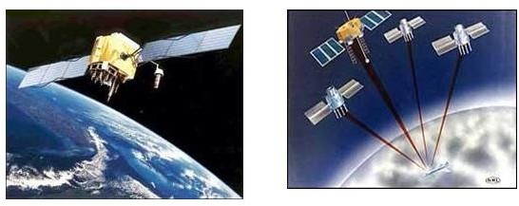The global positioning system was developed by the U.S. military and then opened to civilian use. It is used today to track planes, ships, trains, cars or anything that moves. Anyone can buy a receiver and track their exact location by using a GPS receiver.

Fig 1.6 GPS satellites orbit at a height of about 19,300 km and orbit the earth once every 12 hours

These satellites are traveling around the earth at speeds of about 7,000 mph. GPS satellites are powered by solar energy. They have backup batteries onboard to keep them running when there's no solar power. Small rocket boosters on each satellite keep them flying in the correct path. The satellites have a lifetime of about 10 years until all their fuel runs out.

At exactly 35,900 km above the equator, the force of gravity is cancelled by the centrifugal force of the rotating universe. This is the ideal spot to park a stationary satellite.

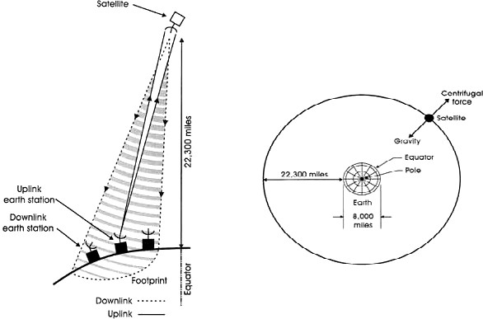

**Fig 1.7** At exactly 35,900 km above the equator, the earth's force of gravity is canceled by the centrifugal force of the rotating universe

### Non Geo-Stationary Orbit

For the geo-stationary case, the most important of these are the gravitational fields of the moon and the sun and the non-spherical shape of the earth. Other significant forces are solar radiation pressure and reaction of the satellite to motor movement within the satellite. As a result, station- keeping maneuvers must be carried out to maintain the satellite within limits of its nominal geostationary position.

An exact geostationary orbit is not attainable in practice, and the orbital parameters vary with time. The two-line orbital elements are published at regular intervals. The period for a geostationary satellite is 23 h, 56 min, 4 s, or 86,164 s. The reciprocal of this is 1.00273896 rev/day, which is about the value tabulated for most of the satellites as in Figure 1.7. Thus these satellites are *geo-synchronous,* in that they rotate in synchronism with the rotation of the earth. However, they are not geostationary. The term *geosynchronous satellite* is used in many cases instead of *geostationary* to describe these near-geostationary satellites.

In general a geosynchronous satellite does not have to be near-geostationary, and there are a number of geosynchronous satellites that are in highly elliptical orbits with comparatively large inclinations. The small inclination makes it difficult to locate the position of the ascending node, and the small eccentricity makes it difficult to locate the position of the perigee. However, because of small inclination, the angles *w* and Ω can be assumed to be in the same plane. The longitude of the sub-satellite point is the east early rotation from the Greenwich meridian.

The *Greenwich sidereal time* (GST) gives the eastward position of the Greenwich meridian relative to the line of Aries, and hence the sub-satellite point is at longitudeand the mean longitude of the satellite is given by



The above equation can be used to calculate the true anomaly and because of the small eccentricity, this can be approximated as v= *M* + 2*e*sin*M.*

## Look Angle Determination

The look angles for the ground station antenna are Azimuth and Elevation angles. They are required at the antenna so that it points directly at the satellite. Look angles are calculated by considering the elliptical orbit. These angles change in order to track the satellite. For geostationary orbit, these angle values do not change as the satellites are stationary with respect to earth. Thus large earth stations are used for commercial communications.

For home antennas, antenna beam-width is quite broad and hence no tracking is essential.

This leads to a fixed position for these antennas.

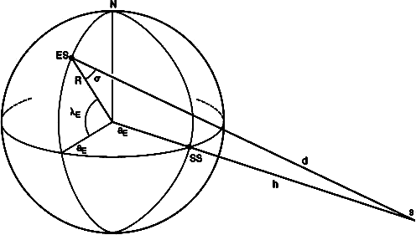

Fig 1.8 Geometry used in determining the look angles for Geostationary Satellites

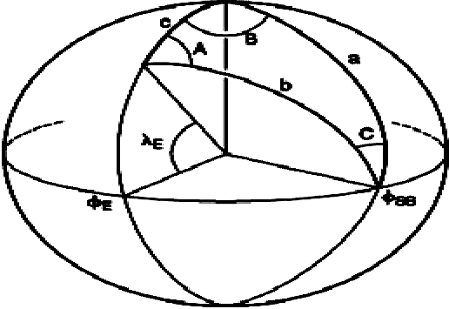

Fig 1.9 Spherical Geometry related to Figure 1.8

With respect to the figure 1.8 and 1.9, the following information is needed to determine the look angles of geostationary orbit.

* + - Earth Station Latitude: λE
    - Earth Station Longitude: ΦE
    - Sub-Satellite Point’s Longitude: ΦSS
    - ES: Position of Earth Station
    - SS: Sub-Satellite Point
    - S: Satellite
    - d: Range from ES to S
    - ζ: angle to be determined

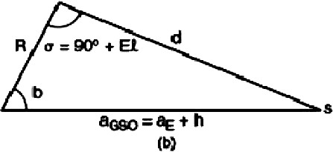

Fig 1.10 Plane triangle obtained from Figure 1.8

Considering Figure 1.9, it’s a spherical triangle. All sides are the arcs of a great circle. Three sides of this triangle are defined by the angles subtended by the centre of the earth.

* + - Side a: angle between North Pole and radius of the sub-satellite point.
    - Side b: angle between radius of Earth and radius of the sub-satellite point.
    - Side c: angle between radius of Earth and the North Pole.
    - a =900 and such a spherical triangle is called quadrantal triangle. c = 900 – λ
    - Angle B is the angle between the plane containing c and the plane containing a.

Thus, B = ΦE-ΦSS

* + - Angle A is the angle between the plane containing b and the plane containing c.
    - Angle C is the angle between the plane containing a and the plane containing b.

Thus, a = 900 c = 900 - λE B = ΦE-ΦSS

Thus, b = arcos (cos B cos λE)

And A = arcsin (sin |B| / sin b)

Applying the cosine rule for plane triangle to the triangle of F i g u r e 1.10,



Applying the sine rule for plane triangles to the triangle of Figure 1.10, allows the angle of elevation to be found:



## Limits of Visibility

The east and west limits of geostationary are visible from any given Earth station. These limits are set by the geographic coordinates of the Earth station and antenna elevation. The lowest elevation is zero but in practice, to avoid reception of excess noise from Earth. Some finite minimum value of elevation is issued. The earth station can see a satellite over a geostationary arc bounded by **+- (81.30)** about the earth station’s longitude.

## Eclipse

It occurs when Earth’s equatorial plane coincides with the plane the Earth’s orbit around the sun. Near the time of spring and autumnal equinoxes, when the sun is crossing the equator, the satellite passes into sun’s shadow. This happens for some duration of time every day. These eclipses begin 23 days before the equinox and end 23 days after the equinox. They last for almost 10 minutes at the beginning and end of equinox and increase for a maximum period of 72 minutes at a full eclipse.

The solar cells of the satellite become non-functional during the eclipse period and the satellite is made to operate with the help of power supplied from the batteries. A satellite will have the eclipse duration symmetric around the time t=Satellite Longitude/15 + 12 hours. A satellite at Greenwich longitude 0 will have the eclipse duration symmetric around 0/15 UTC +12hours = 00:00 UTC.

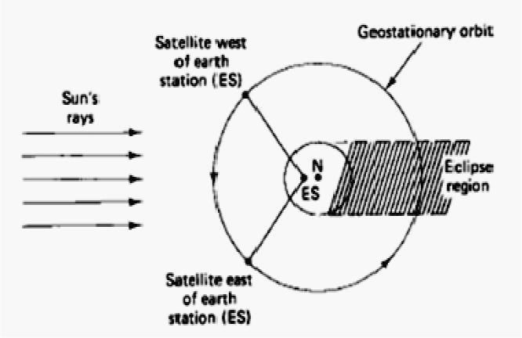The eclipse will happen at night but for satellites in the east it will happen late evening local time. For satellites in the west eclipse will happen in the early morning hour’s local time. An earth caused eclipse will normally not happen during peak viewing hours if the satellite is located near the longitude of the coverage area. Modern satellites are well equipped with batteries for operation during eclipse.

Fig 1.11 A satellite east of the earth station enters eclipse during daylight busy hours at the earth station. A Satellite west of earth station enters eclipse during night hours

## Sub satellite Point

Sub satellite Point is the point at which a line between the satellite and the center of the Earth intersects the Earth’s surface. The location of the point is expressed in terms of latitude and longitude. If one is in the US it is common to use -

* + - Latitude – degrees north from equator
    - Longitude – degrees west of the Greenwich meridian

The Location of the sub satellite point may be calculated from coordinates of the rotating system as:

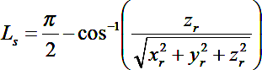

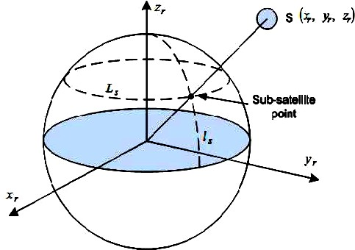

## Sun Transit Outage

Fig 1.12 Sub satellite Point

Sun transit outage is an interruption or distortion of geostationary satellite signals caused by interference from solar radiations. Sun appears to be an extremely noisy source which completely blanks out the signal from satellite. This effect lasts for 6 days around the equinoxes. They occur for a maximum period of 10 minutes.

Generally, sun outages occur in February, March, September and October, that is, around the time of the equinoxes. At these times, the apparent path of the sun across the sky takes it directly behind the line of sight between an earth station and a satellite.

As the sun radiates strongly at the microwave frequencies used to communicate with satellites (C-band, Ka band and Ku band) the sun swamps the signal from the satellite. The effects of a sun outage can include partial degradation, that is, an increase in the error rate, or total destruction of the signal.

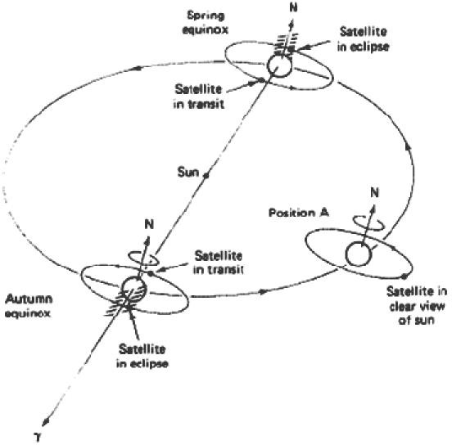

Fig 1.13 Earth Eclipse of a Satellite and Sun transit Outage

## Launching Procedures

### Introduction

Low Earth Orbiting satellites are directly injected into their orbits. This cannot be done in case of GEOs as they have to be positioned 36,000kms above the Earth’s surface. Hence Launch vehicles are used to set these satellites in their orbits. These vehicles are reusable. They are also known as Space Transportation System (STS). When the orbital altitude is greater than 1,200 km it will be expensive to inject the satellite in its orbit directly. For this purpose, a satellite must be placed to a transfer orbit between the initial lower orbit and destination orbit. The transfer orbit is commonly known as Hohmann-Transfer Orbit.

### Orbit Transfer

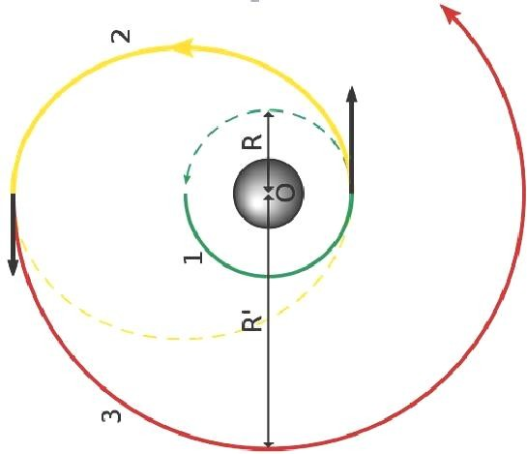

**Fig 1.14** Orbit Transfer Positions

### Hohmann Transfer Orbit

This manoeuvre is named after the German Civil Engineer Walter Hohmann, who first proposed it. He didn't work in rocketry professionally but was a key member of Germany's pioneering Society for Space Travel that included people such as Willy Ley, Hermann, and Werner von Braun. He published his concept of how to transfer between orbits in his 1925 book, The Attainability of Celestial Bodies.

The transfer orbit is selected to minimize the energy required for the transfer. This orbit forms a tangent to the low attitude orbit at the point of its perigee and tangent to high altitude orbit at the point of its apogee.

## Launch Vehicles and Propulsion

The rocket injects the satellite with the required thrust into the transfer orbit. With the STS, the satellite carries a perigee kick motor which imparts the required thrust to inject the satellite in its transfer orbit. Similarly, an apogee kick motor (AKM) is used to inject the satellite in its destination orbit.

Generally it takes 1-2 months for the satellite to become fully functional. The Earth Station performs the Telemetry Tracking and Command function to control the satellite transits and functionalities. Thrust is a reaction force described by Newton's second and third laws. When a system expels or accelerates mass in one direction the accelerated mass will cause a force of equal magnitude but opposite direction on that system.

Kick Motor refers to a rocket motor regularly employed on artificial satellites destined for a geostationary orbit. As the vast majority of geostationary satellite launches are carried out from spaceports at a significant distance away from Earth's equator.

The carrier rocket would only be able to launch the satellite into an elliptical orbit of maximum apogee 35,784-kilometres and with a non-zero inclination approximately equal to the latitude of the launch site.

TT&C: It is a sub-system where the functions performed by the satellite control network to maintain health and status, measure specific mission parameters and processing over time a sequence of these measurement to refine parameter knowledge, and transmit mission commands to the satellite.

### Transfer Orbit

It is better to launch rockets closer to the equator because the Earth rotates at a greater speed here than that at either pole. This extra speed at the equator means a rocket needs less thrust and less fuel to launch into orbit.

In addition, launching at the equator provides an additional 1,036 mph of speed once the vehicle reaches orbit. This speed bonus means the vehicle needs less fuel, and that freed space can be used to carry more pay load.

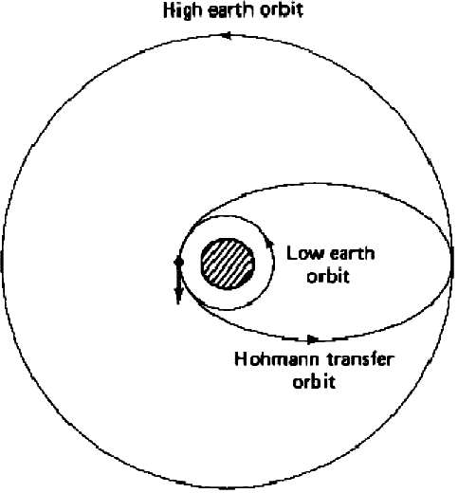

**Fig 1.5** Hohmann Transfer Orbit

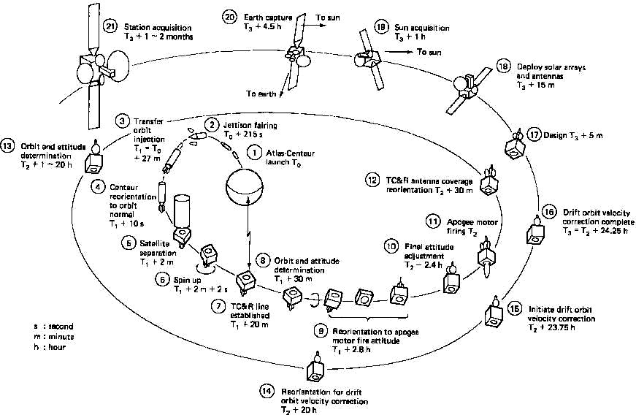

**Fig 1.16** Launching stages of a GEO

### Rocket Launch

A **rocket launch** is the takeoff phase of the flight of a rocket. Launches for orbital spaceflights, or launches into interplanetary space, are usually from a fixed location on the ground, but may also be from a floating platform or potentially, from a super heavy An-225-class airplane. Launches of suborbital flights (including missile launches), can also be from:

* + - a missile silo
    - a mobile launcher vehicle
    - a submarine
    - air launch:
    - from a plane (e.g. Scaled Composites Space Ship One, Pegasus Rocket, X-15)
    - from a balloon (Rockoon, daVinci Project (under development))
    - a surface ship (Aegis Ballistic Missile Defense System)
    - an inclined rail (e.g. rocket sled launch)

**MCQ – Test**

1. The satellite is accelerating as it orbits the earth.  
    a) True  
    b) False
2. Why does the orbit take the shape of an ellipse or circle?  
   a) Position can be easily determined  
   b) Consume less fuel  
   c) Most efficient geometry  
   d) Better coverage on earth
3. The direction of orbit in the same direction of earth rotation is called ______  
   a) Retrograde  
   b) Posigrade  
   c) Perigee  
   d) Apogee
4. When is the speed of the satellite maximum in an elliptical orbit?  
   a) Retrograde  
   b) Posigrade  
   c) Perigee  
   d) Apogee
5. The time period taken by the satellite to complete one orbit is called ________  
   a) Lapsed time  
   b) Time period  
   c) Sidereal period  
   d) Unit frequency
6. The period of time that elapses between the successive passes of the satellite over a given meridian of earth longitude is called as _____________  
   a) synodic period  
   b) Lapsed time  
   c) Time period  
   d) Sidereal period
7. What is the angle of inclination for a satellite following an equatorial orbit?  
   a) 0°  
   b) 180°  
   c) 45°  
   d) 90°
8. The angle between the line from the earth station’s antenna to the satellite and the line between the earth station’s antenna and the earth’s horizon is called as ___________  
   a) Angle of inclination  
   b) Angle of elevation  
   c) Apogee angle  
   d) LOS angle
9. To use a satellite for communication relay or repeater purposes what type of orbit will be the best?  
   a) Circular orbit  
   b) Elliptical orbit  
   c) Geosynchronous orbit  
   d) Triangular orbit
10. What is the point on the surface of the earth that is directly below the satellite called?  
    a) Satellite point  
    b) Subsatellite point  
    c) Supersatellite point  
    d) Overhead point

**Answers: 1. (a), 2. (a), 3. (b), 4. (c),5. (c),6. (a),7. (a),8. (b),9. (c), 10. (b)  
  
  
Assignment:**

* + - 1. State Kepler’s Laws.
      2. Give the Uplink and Downlink frequencies for Satellite Communication.
      3. What is sidereal time?
      4. What are the conditions required for an orbit to be stationary?
      5. Mention the different services of satellite systems.
      6. Define polar orbiting satellites.
      7. Define Apogee and Perigee.
      8. What is Line of apsides?
      9. Define ascending and descending node.
      10. Define inclination.

**Conclusion:**

1. Students can define orbital mechanics and launchers
2. They can find Look Angle
3. To find Orbital perturbations and Orbit determination
4. Able to know the applications.

**TEXT BOOKS:**

1. Satellite Communications – Dennis Roddy, McGraw Hill, 2nd Edition, 1996.
2. Satellite Communications – Timothy Pratt, Charles Bostian and Jeremy Allnutt, WSE, Wiley Publications, 2nd Edition, 2003.
3. Satellite Communications Engineering – Wilbur L. Pritchard, Robert A Nelson and Henri G.Suyderhoud, 2nd Edition, Pearson Publications, 2003.

**REFERENCES:**

1. Satellite Communications: Design Principles – M. Richharia, BS Publications, 2nd Edition, 2003.
2. Fundamentals of Satellite Communications – K.N. Raja Rao, PHI, 2004